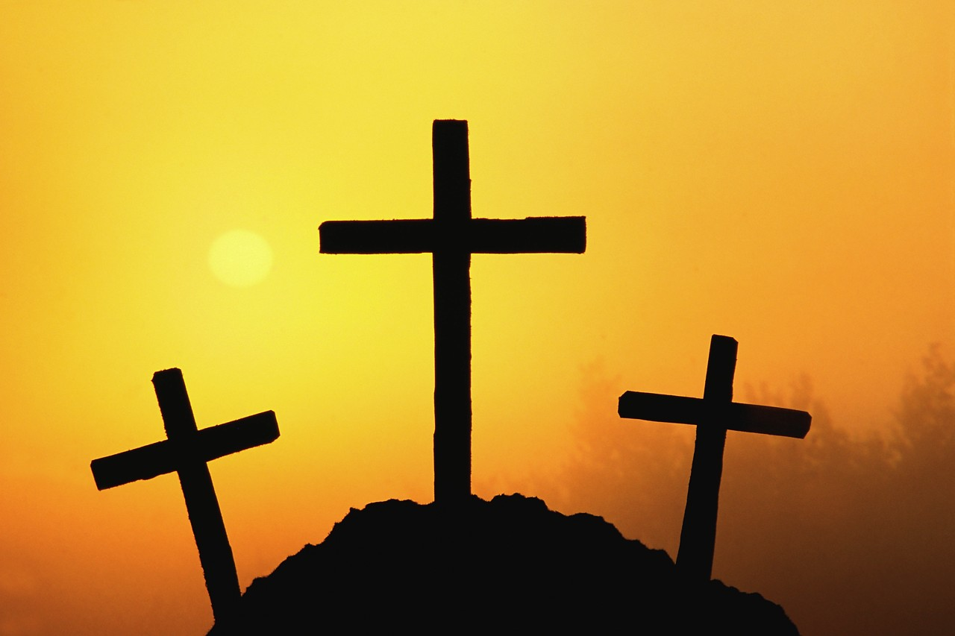
Spanish Easter Quiz

- What is La Semana Santa called in English?

- What do the Spanish people call Good Friday?

- What kind of costume do the nazareños wear in the processions ?

- What’s the name in Spanish for a float in the Easter processions?

- What do the men who carry the floats practise with?

- Can you name 2 ingredients you would need to make torrijas?

- Write down another piece of information that you found interesting.

How do you say Happy Easter in Spanish?

¡ - - - - - - - - - - - !

